MID-YEAR MONITORING REPORT
2015/2016

l TABLE OF CONTENTS

Part 1 In-Year Report
1 Mayoral Speech 4-5
2 Resolution 6-7
3 Executive summary 8-12
4 Municipal manager’s quality certification 13
5 In-year budget statement tables 14-21
Part 2 Supporting documentation
1 Debtors’ Analysis 22
2 Creditors’ Analysis 23

3 Investment portfolio analysis 24
4 Allocation and grant receipts and expenditure 25-27
5 Councillor and board member allowances and employee benefits 28-29
6 Material variances to the service delivery and budget implementation plan 29
7 Performance Indicators 30-31
8 Capital programme performance 32
9 Charts 33-35
10 Excel Mid-Year Report 36

- LIST OF FIGURES AND TABLES

No Description Page
Table 1 Budget Summary (Table C1) 14
Table 2 Budgeted Financial Performance (standard classification) (Table C2) 15

Table 3 Budgeted Financial Performance (Revenue and Expenditure by 16
municipal vote) (Table C3)

Table 4 Financial Performance (revenue and expenditure) (Table C4) 17

Table 5 Capital Expenditure (Table C5) 18-19

Table 6 Financial Position (Table C6) 20
Table 7 Cash Flow (Table C7) 21

Table 8 Debtors’ Analysis (Table SC3) 22

Table 9 Creditors’ Analysis (Table SC4) 23

Table 10 Investment portfolio analysis (Table SC5) 24

Table 11 Allocation and grant receipts and expenditure (Table SC6 & SC7(1),(2)) 25-27

Table 12 Councillor and board member allowances and employee benefits 28-29
(Table SC8)

Table 13 Material variances (Table SC1) 29

Table 14 Performance indicators (Table SC2) 30-31

Table 15 Capital programme performance (Table SC12) 32

Table 16 Charts 33-35

- MAYORAL SPEECH

COUNCILLORS
COMRADES, FRIENDS
LADIES & GENTLEMEN
MUNICIPAL MANAGER, YOUR MANAGEMENT TEAM & MUNICIPAL OFFICIALS
INTRODUCTION:

In terms of Section 72(1), (2) and (3) of the Municipal Finance Management Act No.56, 2003 Chapter 8, the mid-year budget and performance assessment report for the period ended 31 December 2014 is submitted before council.

Section 72(3) further stipulates that as part of the assessment, recommendations must be made whether an adjustment budget is necessary, taking into consideration the revised projections for revenue and expenditure to the extent that this may be necessary. The mid-year budget and performance assessment report must beconsistent with the monthly budget statements on the implementation of the annual budget in accordance with the Service Delivery Budget Implementation Plan (SDBIP) for the first half of the financial year and be submitted to the Mayor, National Treasury and the relevant Provincial Treasury.

The format of the report is specified in the Municipal Budget and Reporting Regulation under schedule C and includes all the required tables, charts and explanatory information. It further prescribed that the mid-year budget and performance assessment report be made public by placing it on the municipal website within five working days of 25 January of each year

MID YEAR BUDGET AND PERFORMANCE ASSESSMENT REPORT

The overall operating results for the first six months ending 31 December 2015 indicate a deficit of R1 625 million. The unfavourable deviation is the net result of lower than budgeted revenue received i.r.o operating grants and traffic fines.

The total capital expenditure for the first six months amounts to R12 649 (31 December 2014:
R 8 845 million) which is higher when compared to the previous financial year (increased spending of R 3 804 million or 43 %)

The net cash inflow from operating activities amounted to R 11 809 (Budget: R 13 478 or a decrease of 12 %) The net cash inflow from investing activities amounted R 12 417
(Budget: R 7 709 or an increase of 61 %)
A net deficit of R 328 000 is recorded for the period ending 31 December 2015 which is mainly due to forecasted cashflow not having realised. This can be attributed to unexpected challenges experienced with the issuing and collection of traffic fines coupled with some grant funding withheld (rollover not apporoved by NT) and the Library grant not yet received.

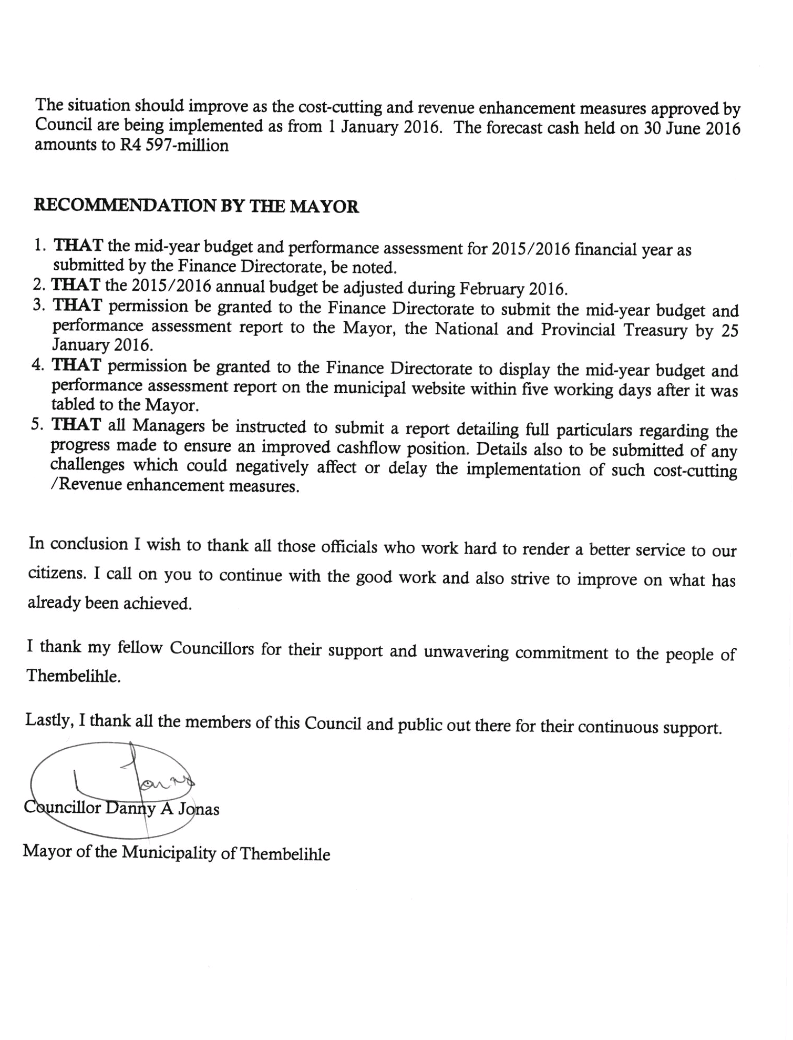

2 RESOLUTION

ITEM NR | ITEM DESCRIPTION | COUNCIL DECISION | RESPONSIBLE PERSON | RESPONDING TO | DUE DATE
SRV4.4/25/1/2016 | Mid-Year Report – Section 72 | That Council approves the Mid – Year Report – section 72.  That the Financial Advisor must take Council through the Mid Year report.  Proposed: Cllr Madekane  Seconded: Cllr Louw | CFO | MM

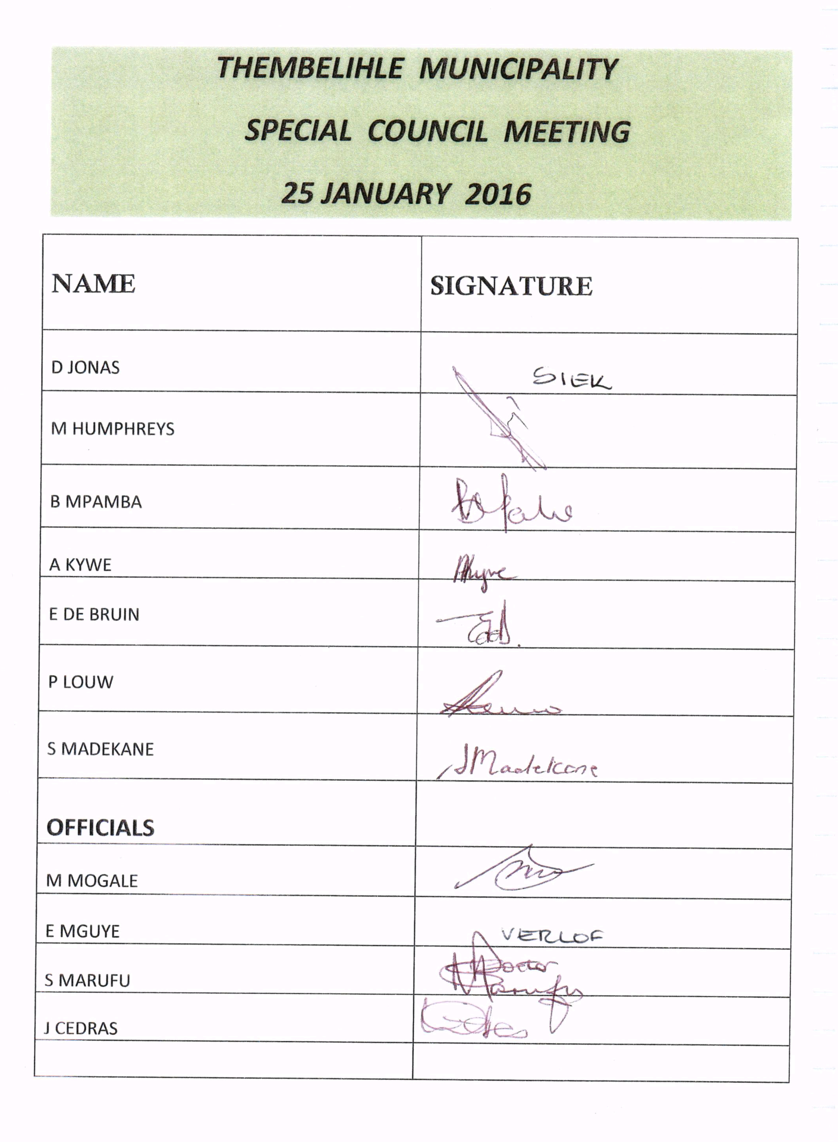

- XECUTIVE SUMMARY

INTRODUCTION:

In terms of Section 72(1), (2) and (3) of the Municipal Finance Management Act No.56, 2003 Chapter 8, the mid-year budget and performance assessment report for the period ended 31 December 2015 is submitted for your consideration.

In terms of the Section 54 (1), (2) and (3) of the Municipal Finance Management Act No. 56, 2003 Chapter 7, the following applies:-

“(1) on receipt of a statement or report submitted by the accounting officer of the Municipality;

In terms of section 72, the mayor must –

(a) Consider the statement or report;

(b) Check whether the municipality’s approved budget is implemented in accordance with the service delivery and budget implementation plan;

(d) Issue any appropriate instruction to the accounting officer to ensure –

(i) That the budget is implemented in accordance with the service delivery and budget implementation plan; and
(ii) That spending of funds and revenue collection proceed in accordance with the budget;

The mid-year budget and performance assessment, taking into account the stipulations of the MFMA, section 72(1) and the Municipal Budget and Reporting Regulations as at 31 December 2015 are attached as ANNEXURE D. The mid-year forecast figures are reflected under the last column with the heading Full Year Forecast.

MID YEAR BUDGET AND PERFORMANCE ASSESSMENT REPORT

We have reached the halfway stage of the 2015/2016 Financial Year and it is time to reflect on all that has happened on the “home-front”

The Municipality of Thembelihle entered into the new financial year of 2015/16 and, although faced with numerous challenges to render the minimum services as required by the Constitution

of the Republic of South Africa and with limited resources at our disposal, was able to commence the year with a positive bank balance of R708, 096.

We managed to approve and subsequently adopt a cash-funded Operational & Capital Budget for the 2015/16 financial year together with the Integrated Development Plan and Service Delivery Budget Implementation Plan for 2015/16. This was adopted by the Council of Thembelihle Municipality on Friday, 29 May 2015.

Even though there is a marked improvement, the Finance Directorate remains under-staffed and some compliance issues with regards to the Municipal Finance Management Act, No. 56 of 2003 remains a hurdle to overcome and manage effectively and efficiently. We managed to report on a monthly basis all relevant matters to the various departments which include the Provincial- & National Treasury as well as the Department responsible for Co-operative Governance-, Traditional Affairs-, & Human Settlements, at their provincial office situated in Kimberley.

Monitoring and regular management of the SDBIP is still a challenge as the shortage of skilled staff is putting more pressure on the current officials. The Performance Management System which should flow from the SDBIP, has not been developed or implemented, but this aspect is receiving attention. Most of the items in our SDBIP have been met despite the lack of a Performance Management System.

Where funding becomes available, albeit a very limited contribution from own funds, prioritised projects as per the IDP are being implemented. Our Capital Expenditure is also in line with or are being planned to be in line with grant funding; mainly MIG and RBIG; and we do not expect to apply for a roll-over of grant funding.

An amount of R 5,5 million was withheld for MIG funding not rolled over for the 2014/2015 financial year and has a direct negative impact on our cash flow.

Our biggest challenge remains cash flow. We have implemented a number of interventions to improve on our cash flow position and some of the more important ones are:
- Continued implementation of the Incentive Scheme which has already resulted in a marked increase in revenue received.
- Debt collection has not taken place for a number of years and Council took a decision to fully implement our Debt Control Policy. The condition is that we have a communication campaign to ensure the community is aware of the steps we will be taking to recover debt
- We will start installing pre-paid electricity meters as soon as possible which will also result in an improved payment ratio.
- We are in the process of selling land as approved by Council which will also ensure a much needed cash injection.

Attached to this report are the following self-explanatory tables.

Table C1: Monthly Budget Statement Summary
Table C2: Monthly Financial Performance by Standard classisfication
Table C3: Monthly Budget Statement - Financial Performance (revenue and expenditure by municipal vote)
Table C4: Monthly Financial Performance by Revenue Source and Expenditure Type.
Table C5: Monthly Capital Expenditure by Vote
Table C6: Monthly Budget Statement Financial Position
Table C7: Monthly Budget Statement Cash Flow

In identifying certain aspects from the SDBIP, the following is a summary thereof:

ASSESSMENT OF THE SDBIP

The following as identified in the SDBIP were executed during the past six months from July 2015 to December 2015:

- Six (6) Monthly budget controls, reconciliation of the General ledger accounts were completed. These reports were communicated to the Municipal Manager and the Council.

- The finalisation of the Annual report of 2014/2015 remains a challence due to capacity constraints as a result of a number of resignations at management level. It is envisaged that the Annual Report will be presented by the Mayor to the Council on 29 February 2016.

- Council meetings took place as per the schedule and Special Council meetings as and when required.

- The following were prepared and adopted by Council:

- Annual Financial Statements according the GRAP standards were submitted to the Office of the Auditor-General on 31 August 2015.

- These statements were adopted by Council and subsequently submitted to the office of the Auditor-General.

The Auditor-General issued a qualified report for the annual financial year ending 30 June 2015. The outcomes of the Audit Report will be discussed in the Annual Report for 2014/15.

There are also areas that are currently a concern as it is hampering progress and development.

AREAS OF CONCERN IN THE SDBIP (SLOW PROGRESS AREAS)

- The proper implementation of by-laws and policies.

- Development and approval of a Tourism strategy for the Municipality

- Development and approval of the LED strategy.

- Review and report on the equity plan.

- Implementation of the training plan.

- Health and safety aspects within the workplace;

- Attendance by communities at Ward committee meetings;

- Building plans control inspections;

- Construction of a taxi rank and other identified projects;

- Development and implementation of a proper Asset Management Plan;

- Housing development plan;

- Development and implementation of Spatial Development Plan;

- Construction of a fully fletched Traffic Station;

- Lack of an effective Performance Management System;

- Other issues are addressed on an ongoing basis.

- Please note that the progress on the above-mentioned matters has been slow mainly because of the funding of such projects and initiatives.

- This has led to the municipality delaying purposefully on the progress of identified matters.

Based on the information reported, it is evident that there are significant variances between the budget and actual figures for the first half of the financial year. It is therefore recommended that the current budget as adopted by Council be reviewed and subsequently adjusted for consideration by Council on Friday, 29 February 2016.

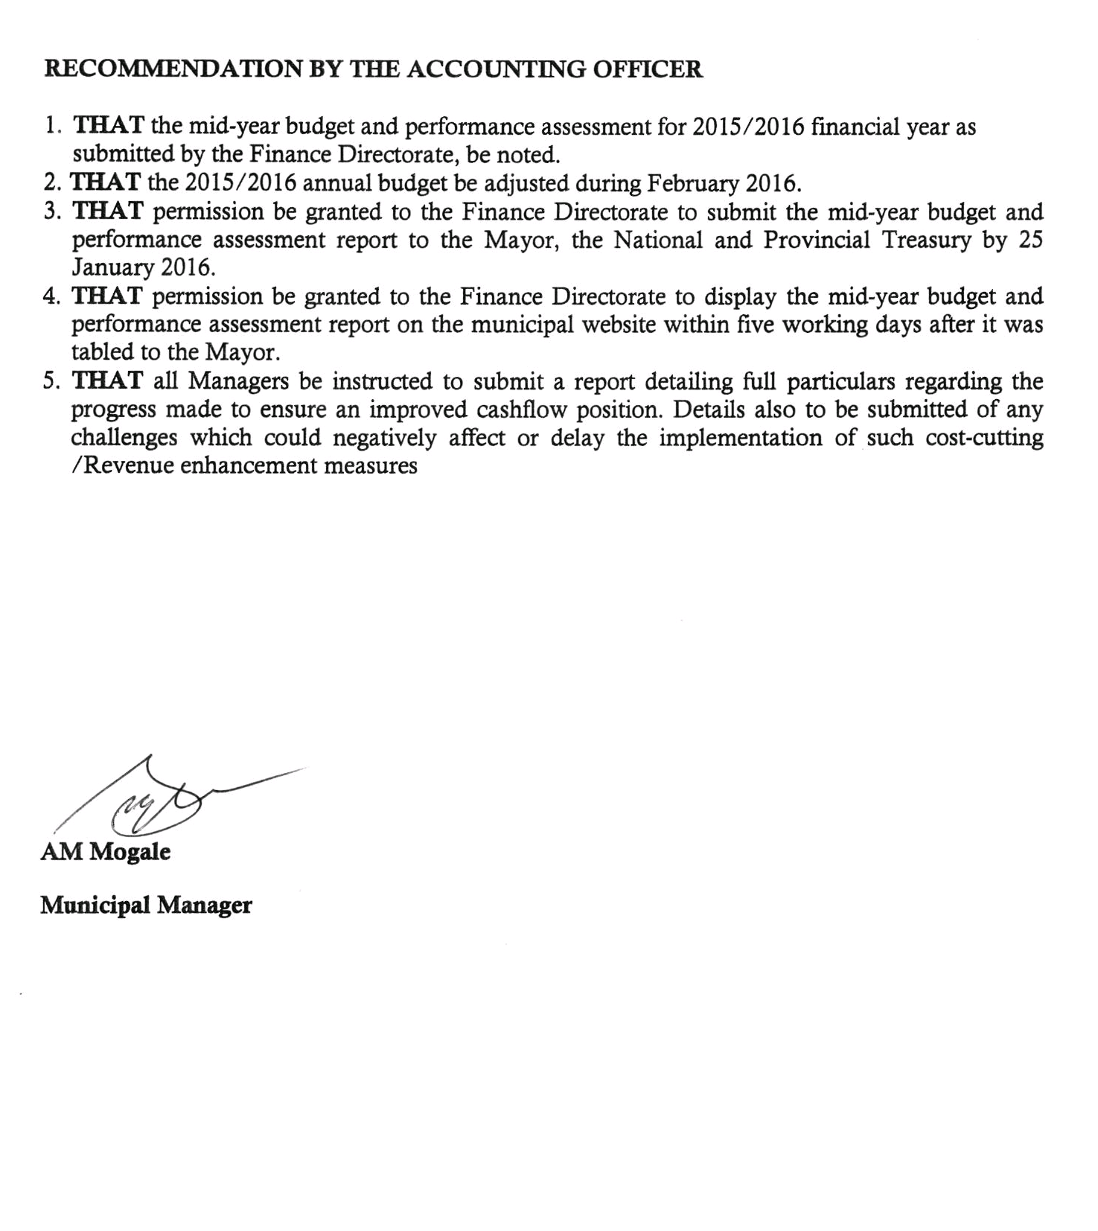
4 QUALITY CERTIFICATE

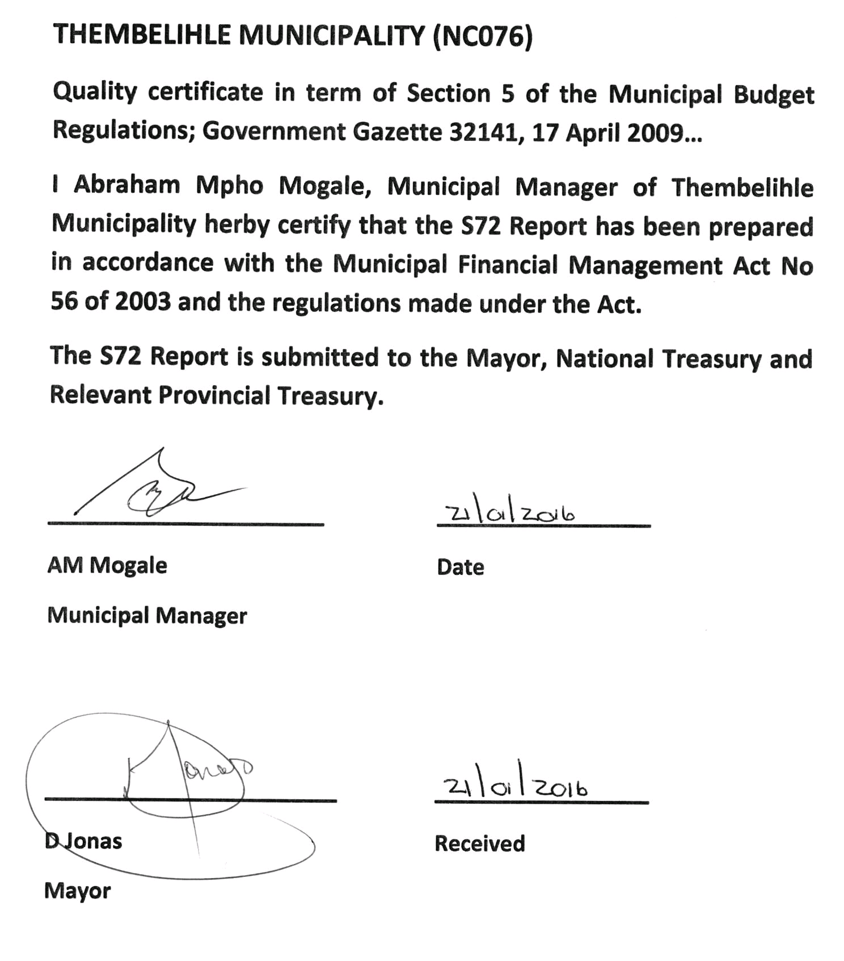

- ANNUAL BUDGET TABLES
The Budget schedules received by Mayor on 20 Janaury 2016:
Table 1 – Budget Summary
Table 1: Budget Summary (Table C1)

Table 2 – Budgeted Financial Performance (Revenue and Expenditure by standard classification)
Table 2 Budgeted Financial Performance (standard classification) Table C2

Table 3 – Budgeted Financial Performance (revenue and expenditure by municipal vote)
Tale 3: Budgeted Financial Performance (revenue and expenditure by municipal vote) (Table C3)

Table 4 – Budgeted Financial Performance (revenue and expenditure)
Table 4: Budgeted Financial Performance (revenue and expenditure) (Table C4)

Table 5 – Budgeted Capital Expenditure by vote, standard classification and funding

Table 5: Budget Capital Expenditure by vote, standard classification and funding (Table C5)

Table 6 – Budgeted Financial Position
Table 6 – Budgeted Financial Position (Table C6)

Table 7 – Budgeted Cash Flows
Table 7: Budgeted cash Flow (Table C7)

Part two - Supporting documents

Table 8 – Debtors’ Analyis
Table 8: Debtors’ Analysis (Table SC3)

Table 9 – Creditors’ Analysis
Table 9: Creditors’ Analysis (Table SC4)
Table 10 – Investment Portfolio Analysis
Table 10 Investment Analysis (Table SC5)

Table 11 – Allocation and grant receipts and expenditure
Table 11 Allocation and grant receipts and expenditure (Table SC6)

Table 11 Allocation and grant receipts and expenditure (Table SC7(1))

Table 11 Allocation and grant receipts and expenditure (Table SC7(2))

Table 12 – Councillor and Board Member allowances and Employee benefits

Table 12 Councillor and Board Member allowances and Employee benefits (Table SC8)

Table 13 - Material Variances
Table 13 Material variances (Table SC1)

Table 14 – Performance Indicatiors

Table 14 Performance Indicators (Table SC2)

Table 15 – Capital programme Performance
Table 15 Capital Programme Performance (Table SC12)

Table 16 – Charts
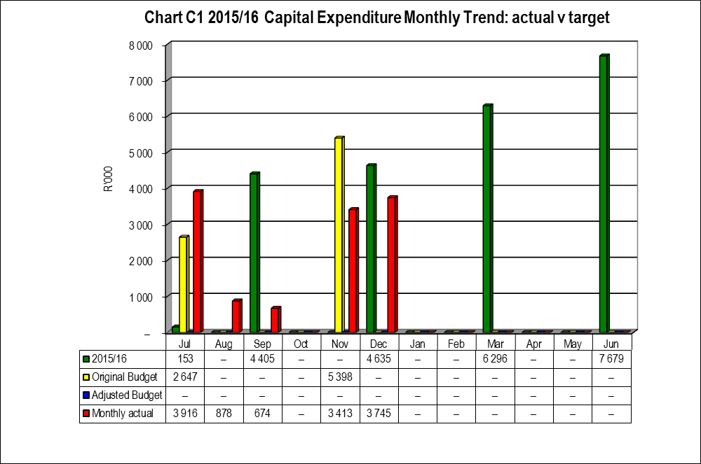

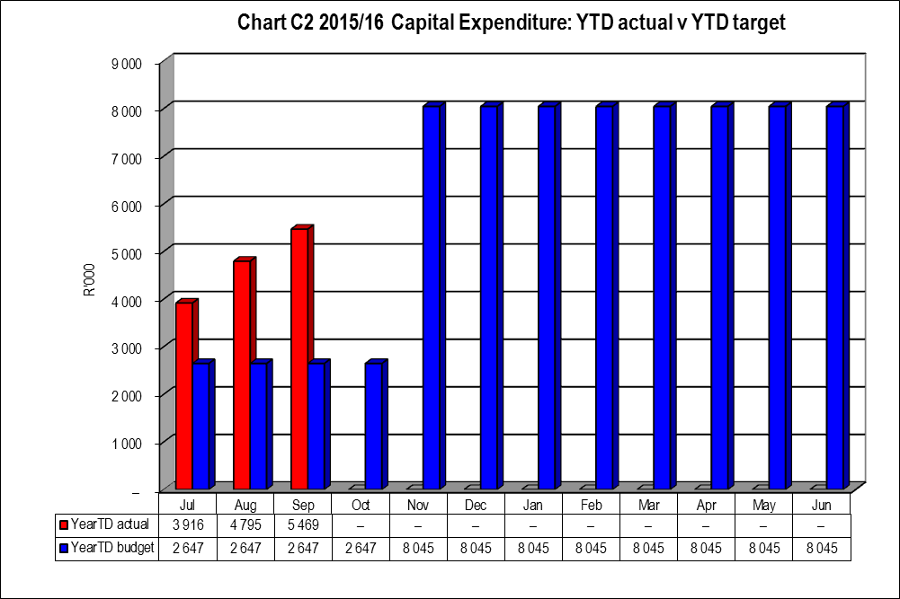

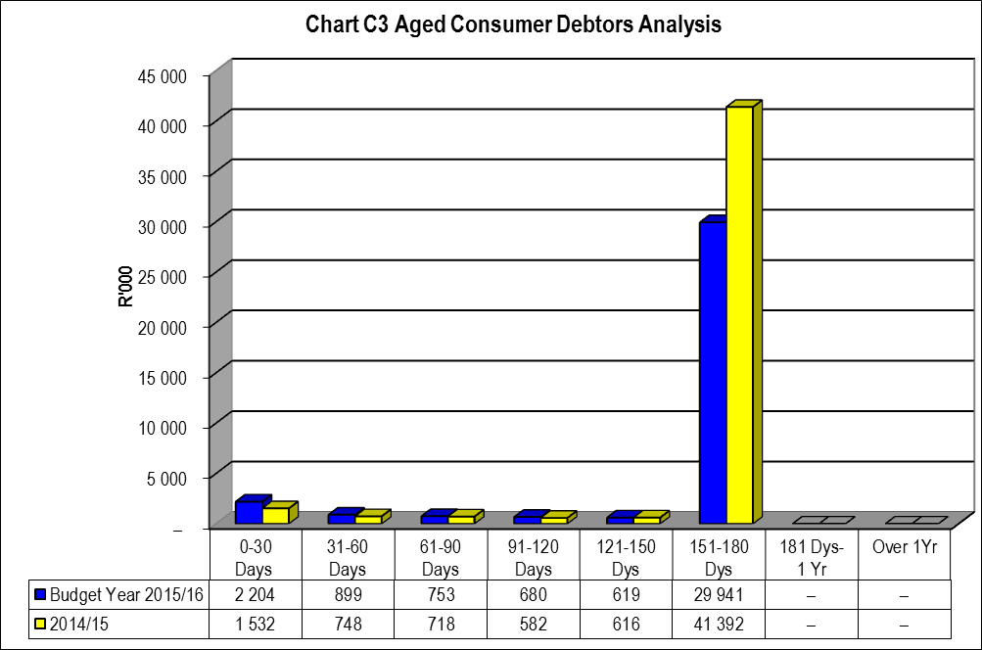

EXCEL MID YEAR REPORT

